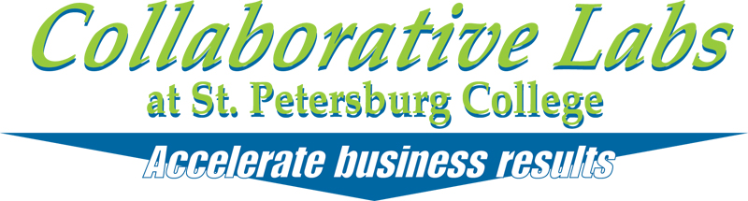

presents

**Bridging the Gap: Collaborative Engagement**

October 24, 2013

**Real-Time Record**

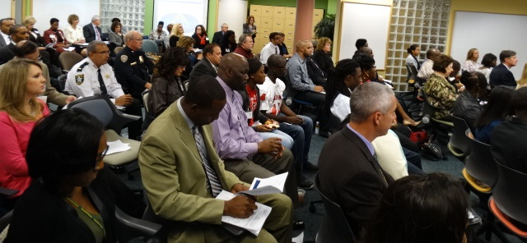

**[Click here to download a Word document of this Real-Time Record](http://www.spcollege.edu/central/collaborative/13/BTG/Bridging_the_Gap_RTR.docx)**

**Building the 5-Year Strategic Vision & 1-Year Action Plan   
to Bridge the Gap in Pinellas County Schools**

**Engagement Objectives**:

1. Build the **5-Year Strategic Vision** to be recognizes as the ***Nation’s Leader in “Bridging the Gap.”***
2. Prioritize the **2014 Actions/Success Metrics/Champions for each Goal** to ***mobilize our success in “Bridging the Gap.”***

|  |  |
| --- | --- |
| **7:30am – 8:15am** | **Registration/Coffee** |
| **8:15am – 8:45am** | **Welcome & Session Objectives**   * Welcome & Setting the Stage for a Productive Engagement: **Dr. Michael Grego, Superintendent, PCS** & **Dr. Bill Law, President, SPC** * Collaborative Labs will provide an overview of the engagement objectives & collaborative process. |
| **8:45am – 10am** | **Building the Ideal 5-Year Vision/Goals to be  Recognized as the Nation’s Leader in Bridging the Gap**  Build the ***Ideal 5-Year Strategic Vision to Bridge the Gap in Pinellas County Schools***. |
| **10am – 12:30pm**  (Working Lunch) | **Prioritizing the 2014 Actions to mobilize our Ideal Future**  Review, Add to and Prioritize the ***2014 Actions for each of the*** ***5 Goal areas, one at a time:***   * *Goal 1: Eliminate the gap between the Pinellas County graduation rates for black students as compared to non-black students.* * *Goal 2: Eliminate the gap between Pinellas County’s proficiency rates on state required assessments for black students as compared to non-black students.* * *Goal 3: Eliminate the gap between the Pinellas County accelerated participation and performance rates for black and nonblack students as measured by the percent within ethnicity.* * *Goal 4: Reduce the disparity in rates of disciplinary infractions between black and non-black students as measured by the percent within ethnicity.* * *Goal 5: Reduce the number of black students being found eligible for Emotional/Behavioral Disabilities*   *After* ***prioritizing 2014 Actions, add Success Metrics/Champions*** *to help mobilize.*  Reconvene as a full group to identify engagement **Highlights** & **Next Steps.** |

|  |  |
| --- | --- |
| **8:15am – 8:45am** | **Welcome & Session Objectives**   * Welcome & Setting the Stage for a Productive Engagement: **Dr. Michael Grego, Superintendent, PCS** & **Dr. Bill Law, President, SPC** * Collaborative Labs will provide an overview of the engagement objectives & collaborative process. |

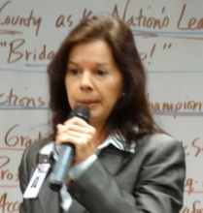**Lori Matway:** Thank you very much. We have plenty of seats in the front row as always. Good morning, I’m Lori Matway. Yes, I’m the one who has been emailing you for the last month. This summit would not be possible without the Juvenile Welfare Board or St. Petersburg College. If you have not had the privilege of being here before, I welcome you to Collaborative Labs which is owned by Saint Petersburg College. Let me introduce to you Dr. Bill Law, the president of St. Petersburg College.

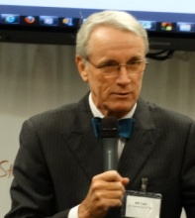**Dr. Bill Law, President, St. Petersburg College:** Welcome. You already have something you have to get over. Mayor David Archie has decided to wear a bowtie. (*Laughter.*) Welcome to St. Petersburg College. I stop because we are all in this together. We are all doing the same work; Mike Grego is working with my team at the college. We want the students to see their way through the school system. The world they face requires more than just a high school diploma. As I look around the room I’m almost the most senior education person in the room. Mike is a great superintendant. We have a great partnership. Mike and I agree on some areas people normally don’t. How many of your have been to Collaborative Labs? (*Raise of hands.*) Great. We need every student to succeed. We need our communities help these students to succeed. I believe every student can succeed but we have to recognize they have different needs; this will help them grow and bring their own energies to the solution. I work at the college because K-12 is too hard. The work that is being done at the elementary schools is fundamental. If there is something the college can do, we will be there. Dr. Grego, welcome to St. Petersburg College you are welcome any time.

Lori: It is my pleasure at this time to welcome our Vice-Chair Peggy O’Shea.

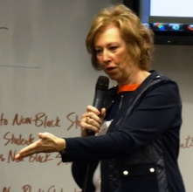**Peggy O’Shea, Vice-Chair, Pinellas County School Board:** Welcome. Thank you for being here today. Dr. Law, when you talk about being the most senior education person in the room, I am about to introduce Linda Lerner, she’s been here for 23 years in Pinellas County. It is my pleasure to serve on the school board. The dedication is unmatched anywhere. We want every student to achieve to the best of their ability. It’s the whole community involved that makes this happen. I thank you all for being here and getting involved with us. The gap is something you hear about everywhere, not just here. But we are getting proactive. The county and cities in this county have really stepped up. Everybody has come together and no one has said no. Stop in and visit a school and see what’s going on in the classrooms. We need to focus on this gap. Thank you all for being here, we appreciate your time.

**Lori:** This meeting would not be possible without Dr. Grego’s leadership.

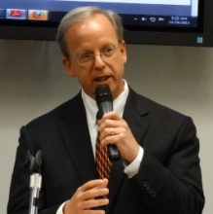**Dr. Michael Grego, Superintendent, Pinellas County Schools:** Thank you so much and thank you to our colleagues. I once heard Dr. Law being introduced in a very different way, it was said, “We never get anything great from Tallahassee, except Dr. Law.” Thanks to your staff and the facilitators that will be working with us today and thank you for providing us with this facility. I have some notes I want to mention, I see members of community based organizations, teachers, students and I suppose many of us are parents, grandparents, aunts and uncles, we have about 100 various individuals from all walks of life. That’s the key of our success. Why do we find ourselves in the same room about to spend a few hours working together? I would propose we share the same concern about the success of students, the achievement gap in the African American students and non-black students. This is our house and we have to improve our community and it’s our responsibility to take action. Today is a call of action to truly work and roll up our sleeves. I find strength in the words of Dr. Carson, our young black males and females, need to know there are options for them so often they become, they can, they can. He was speaking from experience. He was born into poverty. His mother, determined to turn her sons around, limited their TV time and required them to read two books and write a book report about them each week. Her friends said they would hate her but she was determined that her sons would have greater opportunities than she did. Her sons did not know it but she could not read. She would pretend to review these pages and would put a check mark at the top of the page. She insisted they take ownership of their learning. At first, Ben resisted the regimen. Very quickly he stretched his imagination Before long he realized he was intelligent. Ben graduated from high school with honors and attended Yale, and then attended The School of Medicine at the University of Michigan. He became the youngest director of pediatric neurosurgery at Johns Hopkins. Ben stated we cannot afford to throw away any of these young people. Simply put we are here to make sure the African American students succeed at higher levels. That’s why we are here today. Let me briefly discuss the goals:

|  |
| --- |
| **5 Goals Areas** |

1. Eliminate the gap between the Pinellas County graduation rates for black students as compared to non-black students.
2. Eliminate the gap between Pinellas County’s proficiency rates on state required assessments for black students as compared to non-black students.
3. Eliminate the gap between the Pinellas County accelerated participation and performance rates for black and non-black students as measured by the percent within ethnicity.
4. Reduce the disparity in rates of disciplinary infractions between black and non-black students as measured by the percent within ethnicity.
5. Reduce the number of clack students being found eligible for emotional/behavioral disabilities.

In addition to aligning everything we do with these goals, I would request the following:

All conversations must be open honest, respectful, part of the solution, not a criticism, no pointing fingers. Look for the right solutions, work together with all of the community agencies, move to the reality where students are expected to take ownership of their education. Stop blaming parents and parents have to stop blaming schools. Let’s focus on how we can help and not criticize. It’s very hard to overcome a student’s lack of desire to succeed. I keep coming back to the fact that students must take ownership of their own learning. We have to think of a mission where we’re not getting students to grade level but above grade level. This is not just a school gap, this is a life gap. That’s why I refer to this as urgent work, this is a life gap. We must create an environment that encourages the students to excel. Students need a mentor that is checking on them. When students know someone cares they don’t want to disappoint them. We know all children will learn. When you put the word “will” instead of “can”, it creates a sense of urgency. Without total agreement we run the risk of maintaining the same gap or even worse, widening the gap. Our district began placing all students in advanced placement and higher level classes and the students rose to the occasion. People balked when Algebra I became a graduation requirement. Guess what? We did it. We must stop looking backwards but learn from our past, there’s a reason why the windshield is so much bigger than the rearview mirror. Let’s continue as a group to move forward. This may be one of our first conversations, but it won’t be our last. You were selected to come here because of your talent and knowledge you can contribute today. There’s something to be said of doing things in smaller groups so I thank you for your time today. I want you to leave today knowing that you have been heard, listened and valued. At this time I’d like our students to please stand and be recognized.  *(Applause.)* This summit is a window into the future. Thank you very much for your time and your willingness and commitment to our future. I want to say from the bottom of my heart, I appreciate your dedication and participation. Thank you.

**Lori:** Thank you for recognizing the students. In your teams today there will be a student in every group, a teacher, and a business leader. I have painstakingly done your breakout groups to make sure everyone is represented. This entire day would not be possible without the staff of the Collaborative Labs, so I want to thank them also.

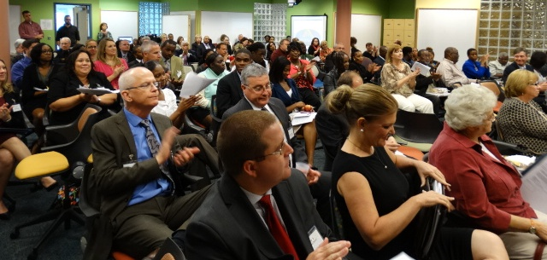

|  |  |
| --- | --- |
| **8:45am – 10am** | **Building the Ideal 5-Year Vision/Goals to be  Recognized as the Nation’s Leader in Bridging the Gap**  Build the ***Ideal 5-Year Strategic Vision to Bridge the Gap in Pinellas County Schools***. |

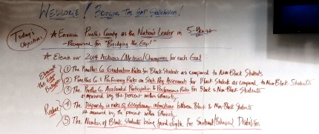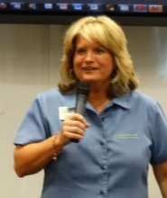**Andrea Henning, Executive Director, Collaborative Labs, St. Petersburg College:** Welcome. You’ve all had the breakfast of champions. We care about this issue a great deal. Let’s make history today. Students, it’s all about you today. Do you feel the love? I appreciate you all dedicating the full day today, we’re here until 6 right? You may be sitting on your agenda and goals. We are only here until 12:30 and you get lunch. How’s that sound? We are in store for 2 missions today. The first is to answer the call and bridge the gap to student success. You may notice our artist is poised and ready to capture this vision you create together. We’ll beam you into the future. Our visioning software is the best way to beam you into the future. We’ll create a magazine cover to see how Pinellas County will be the national leader in bridging the gap. The beauty of this activity is you can see the common themes. That is mission #1. Once we have the vision, we need to get down to business and look at each of the 5 goals. The community leaders have populated action items, you can add additional items. Then we will prioritize the items and mobilize. This is a robust activity. How many of you are in teams 1 – 6? You are in the Forest. You will head out the back and take a left. You will find your team numbers. 7 – 12, you will go to the Water lab. You will find your team. When you get there you will appoint a keyboard savvy person, maybe the students, identify 2019 headlines for why the county is the national leader for bridging the gap. Then copy and paste the one all of you can agree on in the headline area. Then in the three sub headline areas, look at the goals and get specific about how we address the goals. Think about the metrics. You can change the title; you can add people, objects and scenery. Let me share with you, you’ll appoint a keyboard person and a spokesperson who will come up to unveil the vision of the future. Music means movement, you’ll move to the lab or the main gathering area when you hear music. Logistics, you are in charge of your destiny. Take breaks as needed. You can store your belongings in the cubbies. Dream big, work hard, have fun.

**Andrea:** The future is before us and it is bright and good. As we are going through the compelling covers please register the common themes. We are going to capture those.

|  |
| --- |
| **Team 1** |

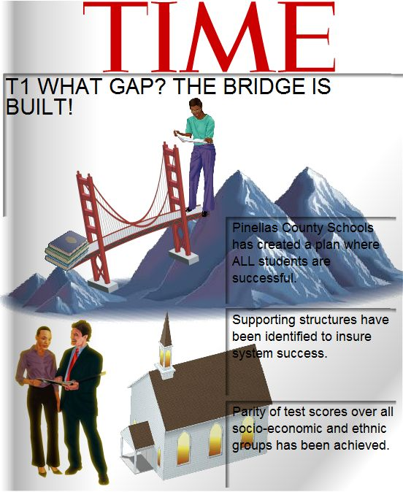

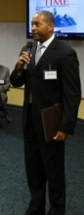**Team 1 Spokesperson:** I’m FrancoisAnthony. The headline is, when we’re talking about bridging the gap, What Gap? The bridge is built it is a done deal. Pinellas County Schools has created a plan where all students are successful. It’s not just a gap, it’s a chasm. We know there is a continuous improvement model in our district that this speaks to. The great art represents a partnership between our students and almost all of our community partners. I say almost because there are some we don’t want to partner with. One thing we can’t forget, our community influence by this church, the young lady has made it from one side of the mountain to the other side.

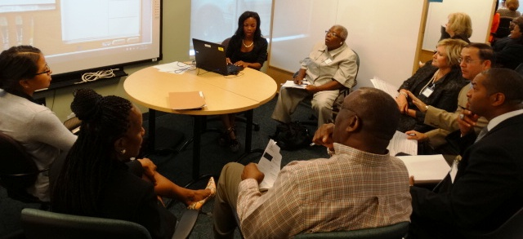**Andrea:** What leaps off the page?

**Comment:** *Community involvement, partnerships, the chasm.*

|  |
| --- |
| **Team 2** |



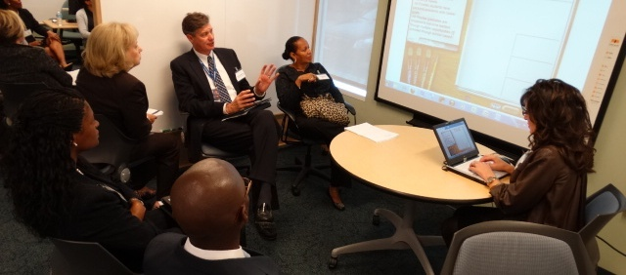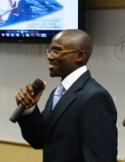**Team 2 Spokesperson:** Hi, I’m Damien Daniels, I go to Gibbs High School. Pinellas County leads the nation in preparing all students for the future by bridging the gap. Community Partnerships to prepare students for current and future workforce. We wanted to make the visual the big gap everything in general, there are two people meeting up with each other. They are going to prepare for the future workforce. Pinellas County increases graduation rate of black males to 100% by bridging the gap. We need everyone in the community to get it done. That’s the only way it’s going to work. Students positively impact the community through their own success and abilities.

**Andrea:** What do you like about the vision?

**Comment:** *The fact that students are giving back to the community. The emphasis is on black males being positive.*

|  |
| --- |
| **Team 3** |

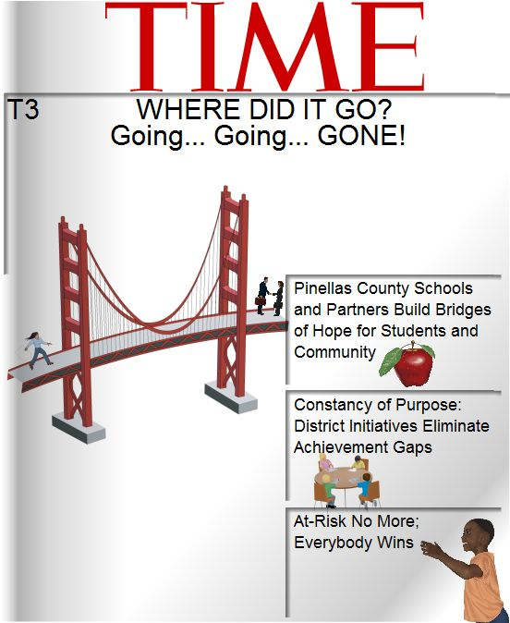

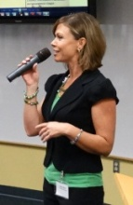

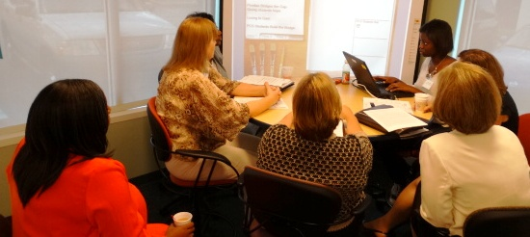**Team 3 Spokesperson:** Hi, I’m a senior. *(Laughter.)* No, I’m Garyn Boyd. So our title is Where id it go? Going, going, gone! We had a hard time finding graphics to represent exactly what we are saying. Pinellas County Schools and partners build bridges of hope for students and community. Our group was a group of women so we debated all different words having to do with partners, we are saying parents, students, churches, and then the second sub-headline is Constancy of purpose: District initiatives eliminate achievement gaps, we debated on this to, everyone has initiatives, it’s our perseverance that makes this work. And then At-risk no more; everybody wins, we found a character that fits exactly what we were thinking of.

**Andrea:** What do you like?

**Comment:** *Partners. I like them taking out the at-risk, that was a mindset change, that really caught my attention.*

|  |
| --- |
| **Team 4** |

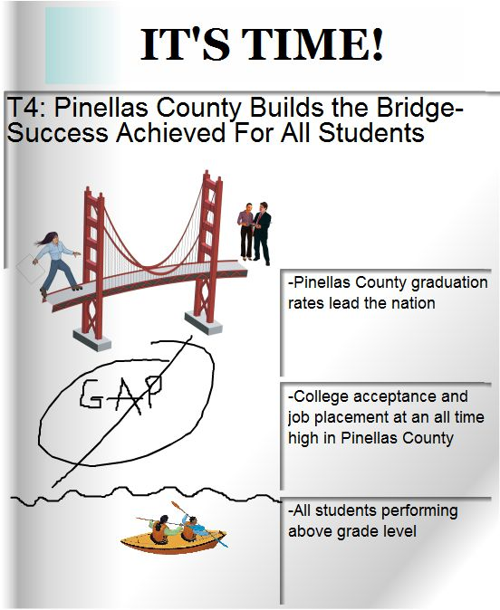

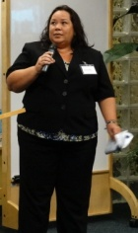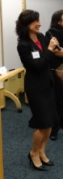**Team 4 Spokesperson:** Hi, we’re Lisa Grant and Nicole Clifton. Our student is a senior at Northeast High School. Our magazine cover changed to It’s Time. Pinellas County builds the bridge, success achieved for all students. There are many ways to get across the bridge, we could skate, or use a boat, this symbolizes all the different ways to achieve success, we are leading the graduation rates in the nation.

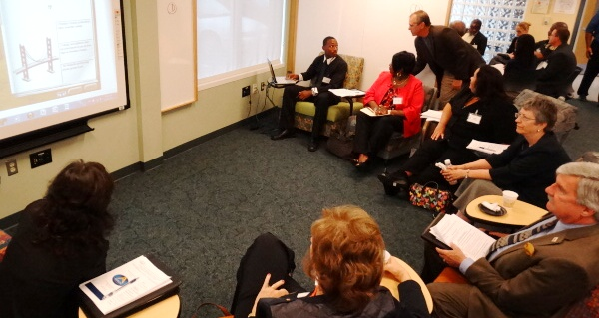Pinellas County graduation rates lead the nation. College acceptance and job placement at an all time high in Pinellas County. All students performing above grade level.

**Andrea:** What do you like in addition to the custom art?

**Comment:** *I like at above grade level, the water because it inspires me, the graduation rates, college and career.*

|  |
| --- |
| **Team 5** |

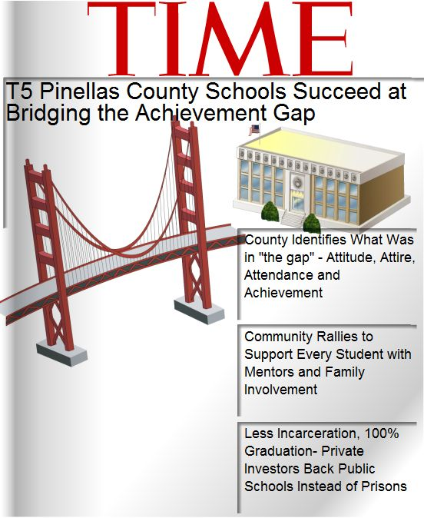

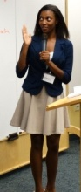**Team 5 Spokesperson:** Marilyn Parker, Lakewood High School. Our title is Pinellas County Schools succeed at bridging the achievement gap. County identifies what was in the gap – attitude, attire, attendance and achievement. Those are some of the key points all the kids have to commit to. Community rallies to support every student with mentors and family involvement, everyone needs to get involved. Less incarceration, 100% graduation, private investors back public schools instead of prisons.

**Andrea:** I’m hearing some good feedback.

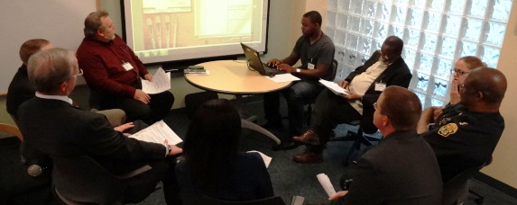**Comment:** *I’m looking at the sub-headlines, I love that. The community is being rallied to support all the students. I like the beautiful speaker.*

|  |
| --- |
| **Team 6** |

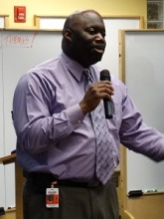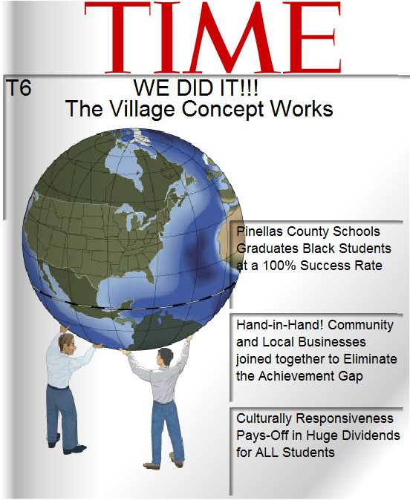

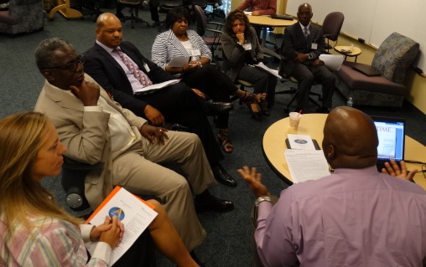**Team 6 Spokesperson:** I’m Reuben Hepburn. We did it, the village concept works. The achievement gap is not a Pinellas County Schools gap, it’s a community problem. Pinellas County Schools graduates black students at a 100% success rate, focusing on those at risk students. Hand in hand. Community and local businesses joined together to eliminate the achievement gap, we talked about offering our students internships. Culturally responsiveness pays off in huge dividends for all students. Making sure our teachers are culturally aware, they see a student and teach to the student and not the community they represent.

**Andrea:** What about this cover speaks to you?

**Comment:** *I like the village concept. Culturally responsive, also in relationship to the school and the whole district.*

|  |
| --- |
| **Team 7** |

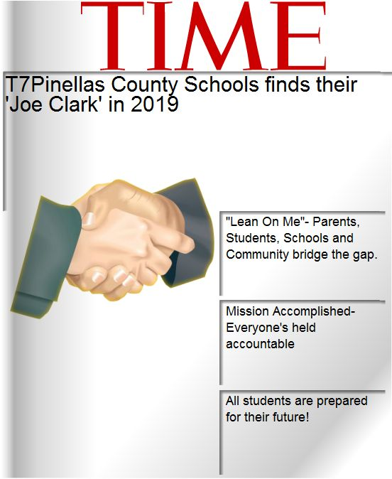

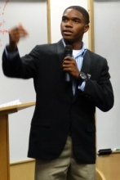**Team 7 Spokesperson:** If you are not familiar with the movie Lean on Me – I’m Ivan Summers, I’m a football player. Pinellas County finds their Joe Clark in 2019. Our idea was to implement the whole Joe Clark attitude. Lean on me, parents, students, schools and community bridge the gap, everyone gets credit here. Mission accomplished, everyone’s held accountable. We are at where we want to be. All students are prepared for their future. We are ready to go.

**Andrea:** What do you like?

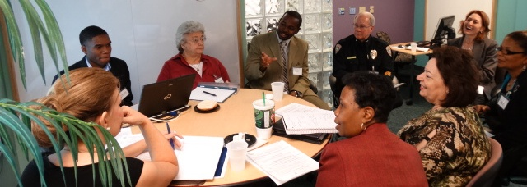**Comment:** *Lean on me, I love the movie we have to lean on one another, you are only as strong as the person in front of you and the one behind. The speaker, he’s a great kid.*

|  |
| --- |
| **Team 8** |

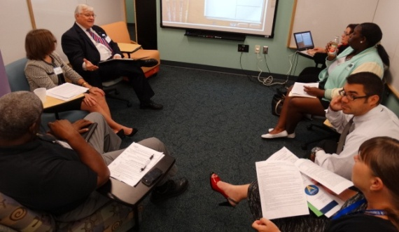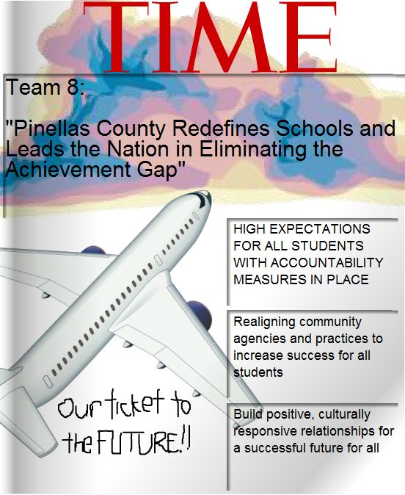

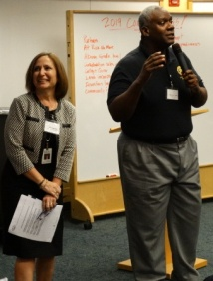**Team 8 Spokesperson:** My name is Randy Lewis, I was appointed because I was the only brother in the group. *(Laughter.)* I want my group to stand up because we were all in this together. We decided Pinellas County redefines schools and leads the nation in eliminating the achievement gap. You have to redefine what is going on in order to do something different.

Rita Vasquez: We were kept focused and real by our student, Regina Thornton. We decided what we need to do is to have high expectations for all students with accountability measures in place for all including teachers, students, administrators, this is about the community. Realigning community agencies and practices to increase success for all students. Lastly, build positive, culturally responsive relationships for a successful future for all.

**Randy:** It does no good to take the child out of the school. If you look at life like Tropicana field, everyone has to have a ticket, but depending on your ticket level, the better your ticket the better your view. In order to get in, you have to have a ticket, no ticket, no admission.

**Andrea:** Anything about this cover that you like?

**Comment:** *Ticket analogy, high expectations. If you set the bar, they will rise to it. We have to hold everyone accountable even the students. Relationships, positive and negative. Culturally responsive relationships.*

|  |
| --- |
| **Team 9** |

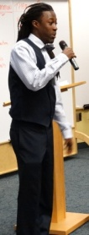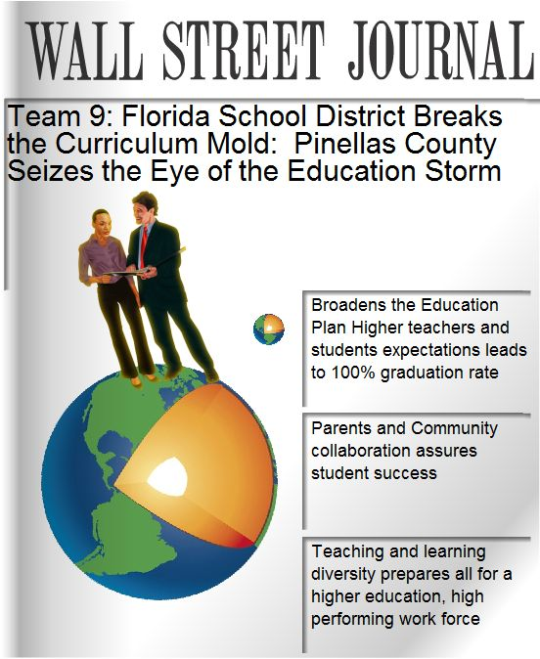

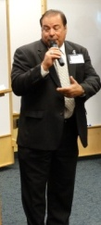**Team 9 Spokesperson:** Mike Mikurak, Juvenile Welfare Board. I keep hearing thee Boca Ciega High School.

**Imhotep Tyler:** I attend thee Boca Ciega High School, we jumped the gap. This is a new leader. Florida School District breaks the curriculum mold. Pinellas County seizes the eye of the education storm.

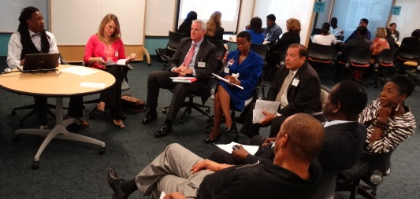Broaden’s the education plan, higher teacher and student expectations lead to 100% graduation rate. Parents and community collaboration assures student success, that’s what drives the success. Teaching and learning diversity prepares all for a higher education, high performing work force. This became left brain right brain in our group. We have that opportunity in Pinellas county, our people standing on the world is what Pinellas county creates the world will take. That’s clearly what will happen through this process.

**Andrea:** What leaps off the page?

**Comment:** *The headline. The Wall Street Journal. The parents and community collaboration, the insurance, the guarantee that it will have a demand, than a command.*

|  |
| --- |
| **Team 10** |

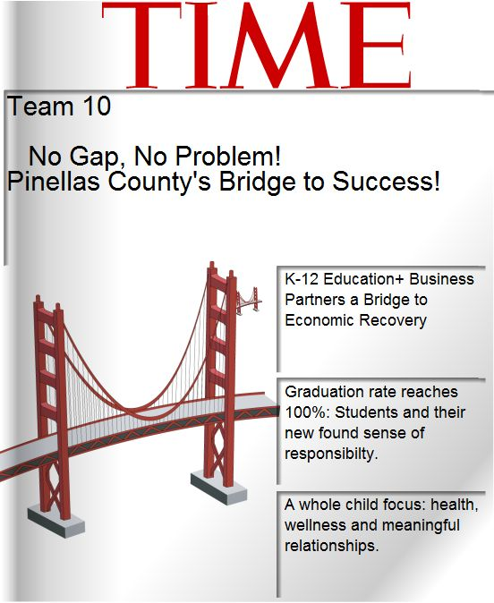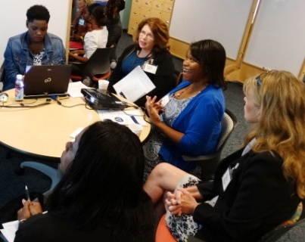

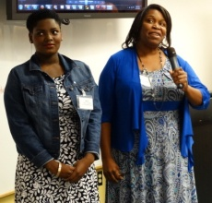

**Team 10 Spokesperson:** Mary Conage, and Jakera Clark-Lawson from Thee Gibbs High School. No gap, no problem. Pinellas County’s bridge to success. K-12 education and business partners a bridge to economic recovery. We thought more globally about the impact of education and how it filters out to the whole society.

**Jakera Clark-Lawson:** Graduation rate reaches 100%, students and their new found sense of responsibility. The teachers can do all they want but if the students don’t take responsibility they won’t go anywhere. They need to know I can’t do anything without me.

Last, a whole child focus, health, wellness and meaningful relationships. When it all boils down, it is a social and an emotional issue. We have found a way to tap into all the gifts a child brings to the world. That’s what we built the bridge with.

**Andrea:** Let’s hear what you like about this one.

**Comment:** *It boils down to the student. Concept of meaningful relationships, that has a positive impact on the achievement gap.*

|  |
| --- |
| **Team 11** |

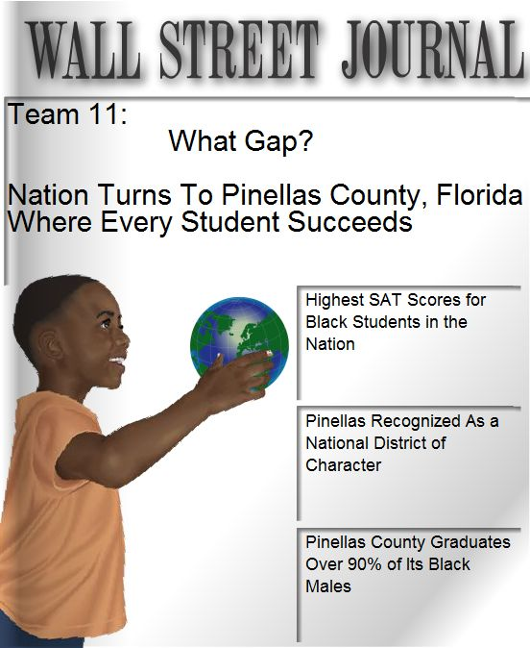

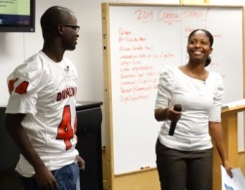**Team 11 Spokesperson:** Hi I’m Kathy and this is our student Alexander Booker. We chose the Wall Street Journal, we want everyone to read about what happens in Pinellas County. What Gap? Nation turns to Pinellas County, Florida where every student succeeds. Highest SAT scores for black students in the nation. Pinellas recognized as national district of character. And last Pinellas County graduates over 90% of its black males. Currently we are at 56% and as you see we have a very young man holding the world in his hand.

**Andrea:** What do you like?

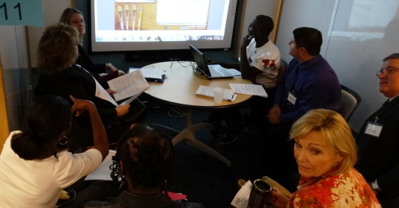**Comment:** *Character, pictures, they are so specific and well defined.*

|  |
| --- |
| **Team 12** |

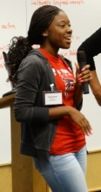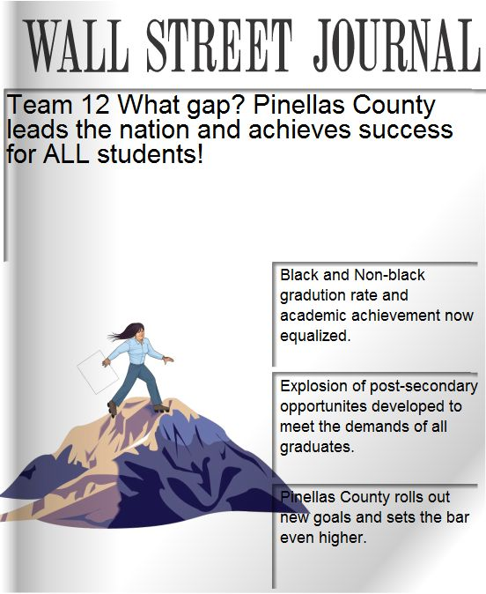

**Team 12 Spokesperson:** I am up here for moral support. I’m Jeannine Welch. Our student was doing the typing and not able to participate in the conversation so we switched. So for those of you who could do both, I’m really impressed.

**Kiyana Scott:** We chose the Wall Street Journal. What Gap? Pinellas County leads the nation and achieves success for all students. Black and non-black graduation rate and academic achievement now equalized. Explosion of post-secondary opportunities developed to meet the demands of all graduates. Pinellas County rolls out new goals and sets the bar even higher.

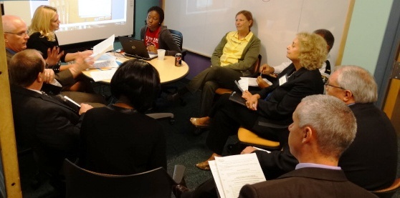**Andrea:** Leaders of our future. What do you like?

**Comment:** *The last statement, sets the bar higher. We want to go beyond that, not only to meet it, but to exceed it. On top of the mountains, it’s so much more than just making it to graduation, what they are going to do after.*

**Andrea:** Ok, what do you think about our future? Alan is going to capture up here common 2019 themes. What did you see as overarching themes?

**Comment:** *Culture, community, relationships, mentors, partners, high expectations, accountability, all students, college and careers beyond high school, partnerships.*

|  |
| --- |
| **2019 Common Themes** |
| * Culture * Community * Relationships * Mentors * High Expectations * Accountability * All Students * Beyond high school * Partnerships |

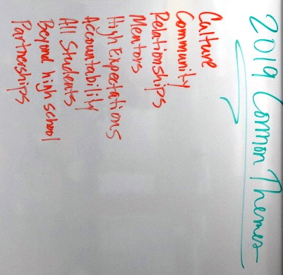

|  |  |
| --- | --- |
| **10am – 12:30pm**  (Working Lunch) | **Prioritizing the 2014 Actions to mobilize our Ideal Future**  Review, Add to and Prioritize the ***2014 Actions for each of the*** ***5 Goal areas, one at a time:***   * *Goal 1: Eliminate the gap between the Pinellas County graduation rates for black students as compared to non-black students.* * *Goal 2: Eliminate the gap between Pinellas County’s proficiency rates on state required assessments for black students as compared to non-black students.* * *Goal 3: Eliminate the gap between the Pinellas County accelerated participation and performance rates for black and nonblack students as measured by the percent within ethnicity.* * *Goal 4: Reduce the disparity in rates of disciplinary infractions between black and non-black students as measured by the percent within ethnicity.* * *Goal 5: Reduce the number of black students being found eligible for Emotional/Behavioral Disabilities*   *After* ***prioritizing 2014 Actions, add Success Metrics/Champions*** *to help mobilize.*  Reconvene as a full group to identify engagement **Highlights** & **Next Steps.** |

**Andrea:** Ok, now we have the 2019 future, let’s go there. Now, we’ll launch into our second activity. We have the 5 goals, each one has its own page. Under it you can see the actions that have been pre-populated as a starter list. As you go to the new team assignments, you will see in front of you Goal 1, eliminate the gap – these here are the action steps. They are in the current order you see them on the page, you can review them together, you can add if you wish. You just go ahead and type it here, hit insert and it will add to the list. After about 10 minutes of reviewing, you will reprioritize these actions in the order which you think is most important. We’ll give you 10 minutes to do that. You’ll prioritize the top 5. You’ll hit vote, and your list will go to this magical place in the sky and we will develop the cumulative list of reprioritizations. Then we’ll take you to another screen. You’ll see the top 5, add a success metric, as well as champion. A metric is a measurement, some way to quantify success. A champion is someone to lead the action, a person, department or group. Any questions? Great, we’ll see you in your team areas.

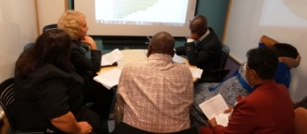 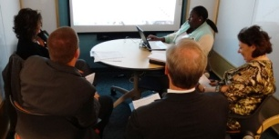

|  |
| --- |
| **Goal 1: 2014 Actions to Eliminate the gap between the Pinellas County graduation rates for black students as compared to non-black students.**  **Complete List of Actions** |

|  |  |
| --- | --- |
|  |  |
| 1 | Recruit retired educators and community members to mentor “At-Risk” black students. Then, assign all "At-Risk" black students in high school (beginning at 9th grade) a graduation mentor/coach who will develop and monitor a personalized learning plan and life plan with the student. “At-Risk” is defined to mean students that scored at Level 1 or Level 2 on both their Grade 8 Reading and Math FCAT tests, or the early warning system. (team 6 ) |
| 2 | Recruit all eligible black students to participate in the AVID program in K-12, which ensures those in the academic middle achieve post-secondary readiness and continue their education beyond high school by supporting their academic success in more rigorous courses through tutoring and direct instruction in critical thinking and study/organizational tools. (Team 8 ) |
| 3 | Ensure all "At-Risk” black students participate in Extended Learning Programs, based on academic need, which take place outside of the regular school day (access opportunities to recover course credits or obtain grade forgiveness, AVID and other enrichment opportunities to meet the promotion or graduation requirements). With transportation provided. (team 12 ) |
| 4 | Conduct meetings with parents/guardians of “At-Risk” black students where an academic success/graduation plan is developed collaboratively with action steps and a defined monitoring plan that includes the schools and parents/guardians in the monitoring process. Starting at elementary school to get them ready early. (team 12 ) |
| 5 | Recruit retired educators and community members to mentor “At-Risk” black students. (team 6 ) |
| 6 | Implement Academic Performance monitoring system for "At-Risk" black students to include identification of students, identification and setting of academic goals, regular data chats regarding progress on goals. |
| 7 | Ensure implementation of a professional development program for culturally responsive instruction for all teachers, to include project based learning strategies to increase rigor and performance, as well as integrating identity lessons in the curriculum to reorient student culture away from the negative images and low expectations associated with African-American males. |
| 8 | Implement standards-based assessments system for all students, to include professional development on analysis of data to inform instructional practices and analysis of data charts by subgroup. |
| 9 | Utilize current technology to assist students and families with future pathways (Team 9 ) |
| 10 | Recruit retired educators and community members to mentor “At-Risk” black students. (team 6 ) |
| 11 | Identify at-risk students (1-2 years below grade level) early (elementary and middle school) for early interventions including mentors and tutors. (team 3 ) |
| 12 | Ensure all black students have access to preparation for End-of-Course assessments (EOC). |
| 13 | Provide parents with sound, accessible advice with support using community collaborative structures on early childhood development and learning. (Team 10 ) |
| 14 | Ensure all black students have access to preparation for post-secondary readiness testing, as well as the multiple types of tests (PERT, ACT, SAT). |
| 15 | Help all students take the PSAT and understand the importance/value of doing well, participate in test preparation opportunities (district and community), and consider retaking to improve their scores. (team 6 ) |
| 16 | Ensure all “At-Risk” black students have access to in-school credit recovery and all other graduation acceleration mechanisms. |
| 17 | Provide opportunities for students to learn more about themselves such as their skill, assets with a support system that will work with them to build on the assets by providing tools to build resiliency, self-esteem and self-worth. (team 7 ) |
| 18 | Provide schools with communication tools (newsletters, website, workshops) to engage parents on a consistent basis. |
| 19 | Early identification with the students by making sure all students are attending school and become more engaged in the process at hand. Also provide early identification students who are chronically absent. (team 11 ) |
| 20 | Establish relationships with parents/guardians of "At Risk" black students where an academic success/graduation plan is developed (team 3 ) |
| 21 | Anti-bullying programs and emotional support (team 1 ) |
| 22 | Provide more anti-suicide watches at school and in the community (team 11 ) |

|  |
| --- |
| **Goal 1: 2014 Actions to Eliminate the gap between the Pinellas County graduation rates for black students as compared to non-black students.**  **Top 5 2014 Actions/Metrics/Champions** |

1. Recruit retired educators and community members to mentor “At-Risk” black students. Then, assign all "At-Risk" black students in high school (beginning at 9th grade) a graduation mentor/coach who will develop and monitor a personalized learning plan and life plan with the student. “At-Risk” is defined to mean students that scored at Level 1 or Level 2 on both their Grade 8 Reading and Math FCAT tests, or the early warning system. (team 6 ) (forest)

* There is a one to one match for every at risk student to have an assigned mentor. (team 3)
* Metric: Increase the percentage of identified 9th grade at risk students assigned a mentor to 100%. (team 6)
* There is a one to five ratio with every at-risk student being represented within a mentor cluster. (team 2)

2. Recruit all eligible black students to participate in the AVID program in K-12, which ensures those in the academic middle achieve post-secondary readiness and continue their education beyond high school by supporting their academic success in more rigorous courses through tutoring and direct instruction in critical thinking and study/organizational tools. (Team 8 ) (forest)

* 80% Eligible Beginning at the grades 6-12 (team 11)

3. Ensure all "At-Risk” black students participate in Extended Learning Programs, based on academic need, which take place outside of the regular school day (access opportunities to recover course credits or obtain grade forgiveness, AVID and other enrichment opportunities to meet the promotion or graduation requirements). With transportation provided. (team 12 ) (forest)

* 100% at risk black students participating in the extended learning programs (ELP) (team 11)

4. Recruit retired educators and community members to mentor “At-Risk” black students. (team 6 ) (forest)

* Number of mentors paired with "At-Risk" students for at least 2 semesters. (team 4)
* Measure data points such as attendence, test scores, behavior, and GPA. (team 4)
* Champion; School based. (team 4)

5. Conduct meetings with parents/guardians of “At-Risk” black students where an academic success/graduation plan is developed collaboratively with action steps and a defined monitoring plan that includes the schools and parents/guardians in the monitoring process. Starting at elementary school to get them ready early. (team 12 ) (forest)

* Success Metric: Utilize student profiles or portfolios to provide evidence of student academic progress quarterly (Team 10)
* Success Metric: (Team 10)
* Conduct at least one parent meeting every semester for all black students. (team 12)
* with your list of at-risk students send out meeting dates to discuss plans for improvement. (team 1)

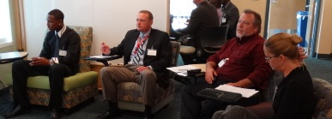 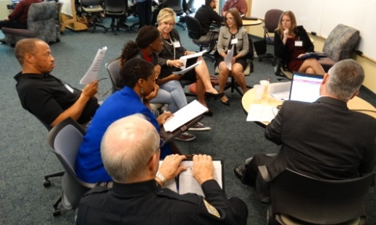

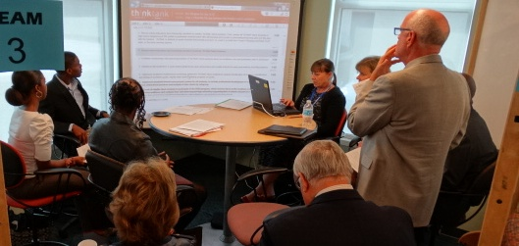 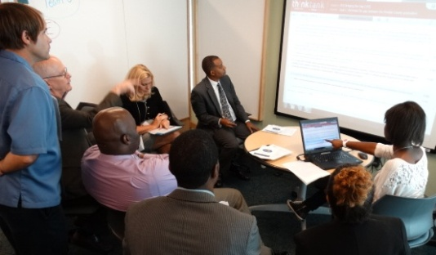

|  |
| --- |
| **Goal 2: Eliminate the gap between Pinellas County’s proficiency rates on state required assessments for black students as compared to non-black students.**  **Complete List of Actions** |

|  |  |
| --- | --- |
|  |  |
| 1 | Analyze student academic performance and assign appropriate intervention to meet the needs of targeted students. |
| 2 | Develop and implement professional development on data analysis and use of assessment data to inform instruction. |
| 3 | Ensure all black students who have not achieved proficiency on a high stakes test participate in Extended Learning Programs and Summer Bridge, which take place outside of the regular school day, to access opportunities to achieve proficiency on EOC or FCAT retake tests or their concordant. |
| 4 | Implement the use of formative assessments to continuously monitor student progress. |
| 5 | Provide schools with Extended Learning Program funds and ensure all black students have access to Extended Learning Program opportunities to prepare for EOC’s and FCAT 2.0. |
| 6 | Develop action plans to encourage attendance/participation in the Extended Learning Program opportunities. |
| 7 | Monitor the usage and quality of Extended Learning Programs in schools. |
| 8 | Provide content specific professional development for teachers in using research-based strategies for differentiating instruction. |
| 9 | Implement school-based Professional Learning Communities focused on collaboration to enhance student learning. |
| 10 | Include annual budget for school improvement that is focused on efforts to improve student achievement and linked to math and reading performance measures. |
| 11 | Support the success of students in the academic middle by providing the opportunity to participate in the AVID elective, which has embedded inquiry-based tutorials to support success in Algebra, Geometry, and Biology. |
| 12 | School District will provide in partnership with the Juvenile Welfare Board (JWB) wrap-around services for qualified elementary and middle schools to increase attendance to after school academic learning opportunities. |
| 13 | Provide schools with communication tools (newsletters, website, workshops) to explain high stakes testing requirements to parents annually. |
| 14 | Build partnerships with colleges and universities to develop achievement supports (k-12) for math, algebra, reading and writing achievement. (team 6 ) |
| 15 | Support Success of students in other EOCs like US History and Middle School Civics (team 6 ) |
| 16 | Implement culturally responsive pedagogy practices and professional development training (know your students, their backgrounds, and build a classroom environment that supports every student) (Team 9 ) |
| 17 | Teachers implement effective, culturally responsive strategies to meet students learning needs. (team 12 ) |
| 18 | Implement a “digital divide” initiative in selected Title I schools to significantly increase out-of- school time learning for students of poverty. |
| 19 | Expand community partners beyond JWB to include other organizations like United Way, Boys and Girls Clubs, and other smaller agencies, etc. (team 6 ) |
| 20 | Provide more opportunities for AVID at the elementary level to support feeder patterns. (Team 8 ) |
| 21 | Creating learning centers that are equipped with computers and personnel etc. (team 12 ) |
| 22 | Provide professional development to all teachers for building culturally responsive classrooms to differentiate instruction (team 3 ) |
| 23 | Increase student knowledge in test-taking skills. (Team 8 ) |
| 24 | Work with community partners to implement programs so that students are not behind when they first enter school (team 11 ) |
| 25 | Implement effective and appropriate culturally responsive teaching environment. If you don't know the students' culture you won't be able to connect them to learning. (team 7 ) |

|  |
| --- |
| **Goal 2: Eliminate the gap between Pinellas County’s proficiency rates on state required assessments for black students as compared to non-black students.**  Top 5 2014 Actions/Metrics/Champions |

1. Analyze student academic performance and assign appropriate intervention to meet the needs of targeted students. (forest)

* Utilize Performance Matters to assist teachers in analyzing student performance. (team 4)
* 100% of the students academic performance analyzed- Scott Mason (team 11)
* Develop a menu of interventions that teachers can easily implement. (team 4)
* Champion; Teacher (team 4)
* 100% of all black students who have not achieved proficiency will participate in Summer Bridge and Extended Learning Programs. (Team 8)
* Utilize Performance Matters (have professional development aligned) to assist teachers analyzing student data on a quarterly basis. Have teachers work collaboratively, as appropriate, create action steps based upon the data. (Team 10)
* Graduation team which targets at risk grades 9-12 students to create an academic success plan. Champion: Senior administrator, guidance counselor, credit recovery team, RTI Team. (team 3)

2. Provide schools with Extended Learning Program funds and ensure all black students have access to Extended Learning Program opportunities to prepare for EOC’s and FCAT 2.0. (forest)

3. Implement the use of formative assessments to continuously monitor student progress. (forest)

* Use the three existing formative assessments in writing, reading, math, and science to gauge a students readiness for proficiency on the FCAT / classroom teacher (Team 9)

4. Ensure all black students who have not achieved proficiency on a high stakes test participate in Extended Learning Programs and Summer Bridge, which take place outside of the regular school day, to access opportunities to achieve proficiency on EOC or FCAT retake tests or their concordant. (forest)

* Provide transportation to participate in ELP. (team 12)
* success metric: number and percent of eligible students participating in ELP programs, target is 100% (team 1)
* Champions (team 1)
* 100% would participate with the ELP Program (team 11)

5. Develop and implement professional development on data analysis and use of assessment data to inform instruction. (forest)

* Metric: (team 6)
* The PD will include culturally responsive instruction. (team 12)
* Metric: 100% of teachers know how to interpret and utilize data to inform instruction. Champions: Assessment Department, Teaching & Learning Department, Higher Education Partners, Professional Development Department, (team 6)

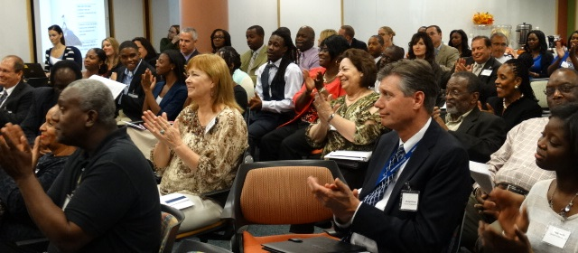

|  |
| --- |
| **Goal 3: Eliminate the gap between the Pinellas County accelerated participation and performance rates for black and nonblack students as measured by the percent within ethnicity.**  **Complete List of Actions** |

|  |  |
| --- | --- |
|  |  |
| 1 | Ensure all black students in this target population receive a personal invitation to register for accelerated coursework, as well as information about what assistance would be available to them if they struggle (tutoring, AVID elective course, homework helpline, online resources, etc.) and how enrolling in accelerated courses benefits them. |
| 2 | Ensure all black students in this target population receive targeted advisement in small group or individual setting related to their course selections. |
| 3 | Collaborate with schools to insure the fidelity of the mission of AVID in supporting underrepresented student participation and performance in rigorous courses. |
| 4 | Conduct ReadiStep testing for all 7th & 8th grade students and PSAT testing for all 9th & 10th grade students, followed by analyzing the data to identify the black students who demonstrate potential for success in rigorous coursework. |
| 5 | Advanced Studies & Academic Excellence staff will conduct semi-annual data review with school leadership to develop action plans to meet this objective, included district support required to meet the goal. |
| 6 | Cross reference the ReadiStep and PSAT data analysis with current student schedules to determine target population for accelerated course recruitment, as well as recruitment for the PCS Talent Identification Program. |
| 7 | Provide reports to the middle and high schools to identify all AVID-eligible black students and assist with recruitment efforts as needed to increase their participation in the AVID program. |
| 8 | Ensure the automatic courses request process is used for math placement in middle school to schedule students into the highest level course in which their data indicates success is probable. |
| 9 | Provide schools with communication tools (information night agendas and materials, newsletters, website) to engage parents in pushing their child to achieve their greatest potential. |
| 10 | Provide opportunities for students to be able to visit colleges, trade schools and businesses (team 11 ) |
| 11 | Conduct screenings of all first grade students (Naglieri) to identify the gifted and talented. (Team 8 ) |
| 12 | Increase participation and performance in rigorous classes in career education that lead to industry certification. (team 6 ) |
| 13 | Ensure a better learning facility for both black and non-black students (team 11 ) |
| 14 | Provide professional development around advanced placement opportunity and criteria. (team 3 ) |
| 15 | Help students to do better not put them down to do poorly in the process (team 11 ) |
| 16 | Understand that ALL students need a champion every now and then (team 11 ) |
| 17 | Provide the tools the students need to reach their goals - the world does not revolve around you - how can you adapt to the new environment but keep your own identity. (team 7 ) |

|  |
| --- |
| **Goal 3: Eliminate the gap between the Pinellas County accelerated participation and performance rates for black and nonblack students as measured by the percent within ethnicity.**  **Top 5 2014 Actions/Metrics/Champions** |

1. Ensure all black students in this target population receive a personal invitation to register for accelerated coursework, as well as information about what assistance would be available to them if they struggle (tutoring, AVID elective course, homework helpline, online resources, etc.) and how enrolling in accelerated courses benefits them. (forest)

* Champion= principals and school counselors (team 11)
* 100% of all eligible students will receive a personal invitation to register for accelerated coursework. (Team 8)
* Champion: Director of academic excellence (team 12)
* Guidance counselors (team 7)
* Champion: College students (team 12)
* Metrics - level of participation (team 7)
* Champion: Office of Advanced Studies (Team 10)

2. Ensure all black students in this target population receive targeted advisement in small group or individual setting related to their course selections. (forest)

* Use ReadiStep and Formative assessment data to organize grouping structures/Guidance and Administration. (Team 9)
* 100% of black students will received targeted advisement in an individual setting; especially during transition years. (Team 8)
* Advisement can be facilitated through articulation conversations with counselors and students during course request time frame. APCs can assist with facilitation as well as guidance counselors. (Team 10)
* Champion: School Counselors, APC's, Principals (Team 8)
* Provide paid time to counselors to meet with targeted groups in the summer. (team 4)

3. Collaborate with schools to insure the fidelity of the mission of AVID in supporting underrepresented student participation and performance in rigorous courses. (forest)

* Champion: Mentors, Tutors and Teachers (Team 8)
* Champion: Parents (Team 8)
* Champion: Director, Advanced Studies (Team 8)
* Champion: K-12 School Counseling Specialist (Team 8)

4. Conduct ReadiStep testing for all 7th & 8th grade students and PSAT testing for all 9th & 10th grade students, followed by analyzing the data to identify the black students who demonstrate potential for success in rigorous coursework. (forest)

* Every students results are analyzed to determined academic gaps and steps needed for appopriate class scheduling (team 11)
* Professional courses for teachers on what rigorous courses really are. (team 12)

5. Advanced Studies & Academic Excellence staff will conduct semi-annual data review with school leadership to develop action plans to meet this objective, included district support required to meet the goal. (forest)

* Review status of action plans every 60 days and adjust as needed (team 11)

|  |
| --- |
| **Goal 4: Reduce the disparity in rates of disciplinary infractions between black and non-black students as measured by the percent within ethnicity.**  **Complete List of Actions** |

|  |  |
| --- | --- |
|  |  |
| 1 | Involve a team of students in the establishment of behavior and discipline plans. (Team 8 ) |
| 2 | Ensure each school has a comprehensive School-wide Behavior Plan with strategies and interventions embedded to improve black student behavior. |
| 3 | Utilize student to student mentoring programs when possible. (Team 9 ) |
| 4 | Provide alternatives to IN and OUT of school suspensions. (Team 9 ) |
| 5 | Target schools with a high percentage of suspension for black students for professional development in culturally responsive positive behavior interventions. |
| 6 | Offer incentives for good behavior (team 5 ) |
| 7 | District will establish a Triage and Training Team to provide targeted training to School Based Leadership Teams and classroom teachers based on school-wide data indicating a need for support. |
| 8 | Review School Improvement Plans to ensure strategies and interventions for behavior improvement are included. |
| 9 | Share expectations with all administrators. |
| 10 | Ensure School-wide Behavior Plans and School Improvement Plans are being implemented with fidelity. |
| 11 | Establish community partnerships to provide the needed resources for On-Campus Intervention Programs at our schools with an elevated number of disciplinary reassignments and/or expulsions. |
| 12 | Monitor and review student data entry in Decision Ed or from various sources in order to provide, as necessary, district support. |
| 13 | Increase participation in diversion programs in lieu of suspension/expulsion. |
| 14 | Update Executive Leadership Team on progress of implementation of School-wide Behavior Plans and School Improvement Plans in accordance with monitoring matrix. |
| 15 | Review status of School-wide Behavior Plans and School Improvement Plans in accordance with monitoring matrix. |
| 16 | Identify in collaboration between school administrators and school resource officers student with chronic discipline problems and develop "proactive problem-solving" for early intervention. (team 6 ) |
| 17 | Increase referrals to community agencies for black students. |
| 18 | Create a Discipline Committee to analyze disciplinary data to inform intervention. (team 2 ) |
| 19 | Implement in partnership with law enforcement a “diversion” program for students and parents. |
| 20 | Recruit and train mentors to represent the parents of students assigned to a diversion program. |

|  |
| --- |
| **Goal 4: Reduce the disparity in rates of disciplinary infractions between black and non-black students as measured by the percent within ethnicity.**  **Top 5 2014 Actions/Metrics/Champions** |

1. Involve a team of students in the establishment of behavior and discipline plans. (Team 8 ) (forest)

* Champion: Guidance Counselors and School Resource Officers (Team 8)
* Champions: School Resource and Community Law Enforcement Officers (team 6)
* Establish a team of students who are representative of the entire school to help contribute to the school behavior plan and it processes. This 'advisory group' would meet quarterly. (Team 10)
* Champion: School Principal (Team 10)
* Students must understand what disrespect is. (team 12)

2. Ensure each school has a comprehensive School-wide Behavior Plan with strategies and interventions embedded to improve black student behavior. (forest)

* Champion: RTI and SBLT (team 3)
* Percentage of schools that implement school-wide behavior plans with fidelity. (team 1)
* Professional Development and implementation within the school-wide community. (team 2)
* Champion: School resource and community police officers (team 6)
* Champion: PBS / Discipline Committee (team 1)

3. Utilize student to student mentoring programs when possible. (Team 9 ) (forest)

4. Provide alternatives to IN and OUT of school suspensions. (Team 9 ) (forest)

* Measure suspension rates from year to year. (team 4)
* Provide social supports. (team 4)
* Partner with families for consquences. (team 4)

5. Offer incentives for good behavior (team 5 ) (forest)

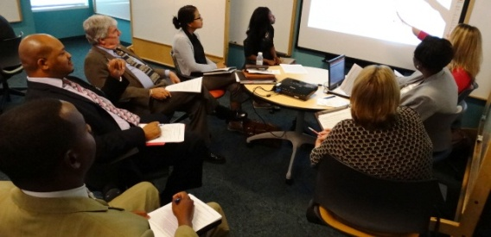 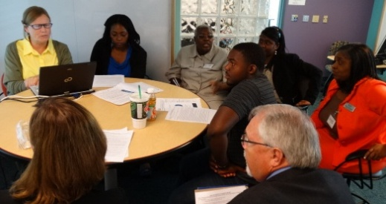

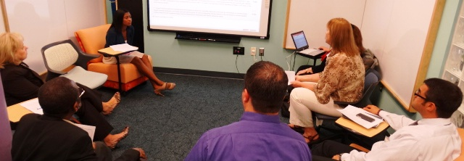

|  |
| --- |
| **Goal 5: Reduce the number of black students being found eligible for Emotional/Behavioral Disabilities.**  **Complete List of Actions** |

|  |  |
| --- | --- |
|  |  |
| 1 | Explore Culturally Responsive Teaching Practices- seek interventions that could assist students and teachers. |
| 2 | District staff will provide Tier 2 and 3 supports/interventions and confirm that interventions are implemented with fidelity. |
| 3 | Providing age appropriate training for students and parents regarding formal environment behaviors. (Team 9 ) |
| 4 | Extensive training will be provided for all Functional Behavior Assessment (FBA) facilitators. |
| 5 | Explicitly teach students expectations and appropriate behavior in community and school environments. Include self-redirection strategies. (team 6 ) |
| 6 | Provide Nonviolent Crisis Intervention Training (CPI) for targeted schools. |
| 7 | Provide intensive professional development in classroom management and behavioral interventions for general education teachers. (team 6 ) |
| 8 | Pinellas County will participate in a pilot to improve systems of professional development, technical assistance and/or dissemination of knowledge about best practices. |
| 9 | District staff will review folders to determine EBD eligibility. |
| 10 | Developing positive relationships with students and families is non-negotiable. (team 7 ) |
| 11 | Increase use and accessibility of academic interventions through the use of technology and online remediation. |
| 12 | Pinellas County will receive technical support in Check and Connect and Systematic Instruction Model (SIM) strategies. |
| 13 | Create a standardized system for identifying the EBD diagnosis. (team 1 ) |
| 14 | Provide an early intervention for social/emotional skills for the success of students between the grades K-12 (team 11 ) |

|  |
| --- |
| **Goal 5: Reduce the number of black students being found eligible for Emotional/Behavioral Disabilities.**  **Top 5 2014 Actions/Metrics/Champions** |

1. Explore Culturally Responsive Teaching Practices- seek interventions that could assist students and teachers. (forest)

* Champions: Teachers and administrators (team 1)
* School Counselors (team 11)
* Percentage of teachers taking advantage of the training. (team 1)
* Metric: 100% of student interns are provided with internships in Title I schools embedded with culturally responsive professional development. (Team 8)
* The district will provide professional development in the area of culturally responsive teaching. Champion: Professional Development Dept. (team 3)
* Professional Development and RTI collaboratively (team 2)
* Champion: ESE Department (Team 10)
* Champion: District multicultural department (Team 10)
* 100% of school staff will participate in professional development in trauma informed care. (Team 8)
* 100% participation by instructional and support staff on an ongoing basis = (team 2)
* Training is not enough - implementation must be monitored and remediated as needed. (team 7)

2. District staff will provide Tier 2 and 3 supports/interventions and confirm that interventions are implemented with fidelity. (forest)

* Champions: ESE Department (Team 8)
* Student Services (team 11)

3. Providing age appropriate training for students and parents regarding formal environment behaviors. (Team 9 ) (forest)

* Champions: SROs, Behavior Specialists, Community Members (team 6)

4. Extensive training will be provided for all Functional Behavior Assessment (FBA) facilitators. (forest)

5. Explicitly teach students expectations and appropriate behavior in community and school environments. Include self-redirection strategies. (team 6 ) (forest)

* School-wide behavior team and TNT district team. (team 2)
* Metric: Develop a principals ESE advisory council. (team 12)
* Champions: Behavior Specialists, Community Members (team 6)
* Number of referrals (team 4)
* Champion; Families (team 4)
* Champion: Principals on the council, to include principals from high needs schools (team 12)
* ESE Department (team 11)
* Champions: Teachers (team 12)

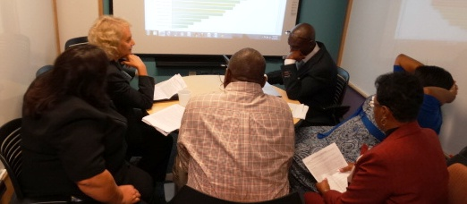 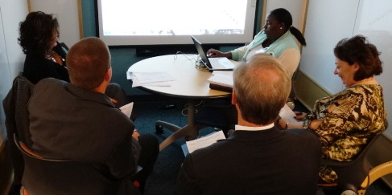

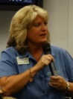**Andrea:** Please come in and have a seat. We’re going to take a few minutes to wrap up a great morning. So if we can hit pause, how do we feel about your work product? Congratulations on defining the future and identifying actions as well as success metrics and champions. What you see in front of you is the work product from today, everything that landed on a whiteboard is transcribed, all of your work, all your action shots, all the magazine covers, it’s all in a complete Real-Time Record that will be completed for you tomorrow. Let’s ask Jonathan, our business illustrator to share with us his rendering of your future.

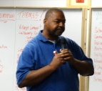**Jonathan:** This is my own take on bridging the gap. I heard different cuts, when I heard that I thought there are two parts of a gap, you have one ledge and the other ledge, you have internally and externally. That student has a part in this, so internally the student has to help fill that gap or bring the plank to finish the bridge. We have a stake in that, we heard Joe Clark and before him there was my dad. Students are missing that piece and parents should be taking part in that, maybe it’s a teacher, a mentor, a peer. We talked about accountability, responsibility, ownership, there’s transference of responsibility. You can do what your parents tell you, but at some point the light comes on and you are responsible and accountable. When you are accountable you can bring that plank and finish the bridge of success. You don’t want to fall in the stream of failure. Well, interpret that as you will.

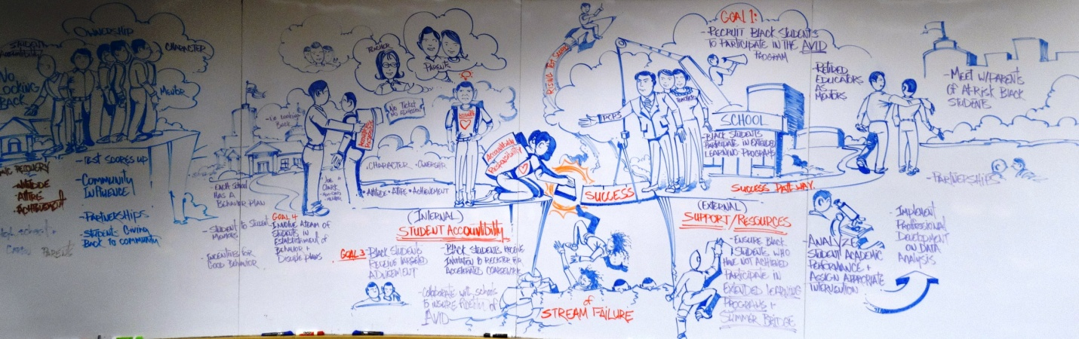

**Andrea:** You’ll have a high resolution shot of this in your Real-Time Record. It has been a privilege to support you today. I’m going to turn it over to Dr. Grego.

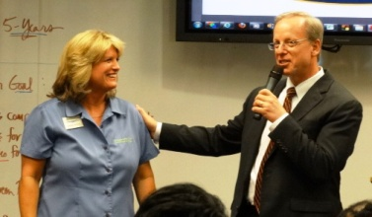**Dr. Grego:** Thank you Andrea, you did a masterful job of getting us back to task. So I started by asking why are we here, whether it be the Time or Wall Street Journal covers, or this work of art, the thing I’m leaving with is the importance of the call to action. You can develop the strategic action many times, but we need to act together. The think I was amazed by was the consistency of our top priorities. Collectively in this room, remember there are many professions in this room, people are thinking the same way. Thank you to our students. The thing I was most reflective of our students comments were to take responsibility. Be that light in your school to shed this is the way we should act, this is yours, the generation that comes, it’s yours. Thank you so much for your attendance today. I want to thank Lori Matway, she put this together.

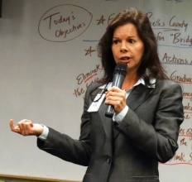**Lori:** Thank you, this is a team effort. We came to the conclusion you want to hear “Lean on Me” today. So I have these participants who will sing us out today.

